LP3: Duality

Notes for CS-8803-GA: Introduction to Graduate Algorithms

Georgia Tech (Dr. Eric Vigoda), Fall 2017

as recorded by Brent Wagenseller

LP Duality: Upper Bound

* Example
  + Setup:

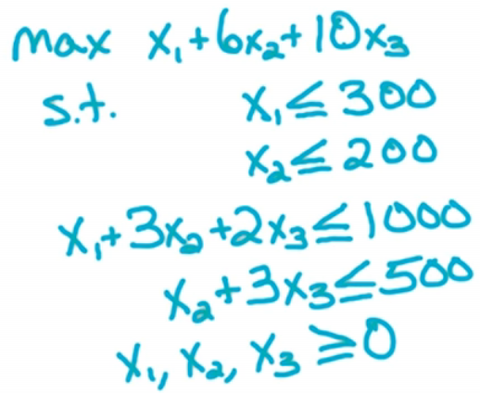

* + 3 variables with 4 constraints plus the non-negativity constraints
  + This is the example we used for the Simplex Algorithm
    - The optimum value was (200, 200, 100)
      * Plugging this into the objective function we get 2400
      * If someone simply gave us this answer, can it be verified?
        + YES, by upper-bounding the objective function
        + We can achieve this upper bound by taking linear combinations of the constraints, as we are certain they are satisfied
* How To Verify Upper Bound
  + So we know the ‘answer’ (2400) and we know there are 4 constraints
    - Since there are 4 constraints we make a new vector Y, and it has 4 elements (y1, y2, y3, y4)
      * We will set this equal to (0, (1/3), 1, (8/3)) but lets not talk about how we got these values just yet
    - We know that any feasible point satisfies the constraints, as well as any linear combination of said constraints
  + Take the linear combination defined by Y and multiply it to their equivalent constraint equation (for both sides)
    - Recall the constraints:
      * x1 <= 300
      * x2 <= 200
      * x1 + 3x2 + 2x3 <= 1000
      * x2 + 3x3 <= 500
    - Converting by multiplying the above with Y (y1, y2, y3, y4), using our example:

(x1y1) + (x2y2) + (x1y3 + 3x2y3 + 2x3y3) + (x2y4 + 3x3y4) <= 300y1 + 200y2 + 1000y3 + 500y4

* + - * Any feasible point X satisfies this inequality for any nonnegative Y
        + If Y IS negative, we have to flip the sign
    - Simplify our equation

x1(y1 + y3) + x2(y2 + 3y3 + y4) + x3(2y3 + 3y4) <= 300y1 + 200y2 + 1000y3 + 500y4

* + - Now plug in the specific Y which we chose and reduce: (0, (1/3), 1, (8/3))

x1 + 6 x2 + 10 x3 <= 2400

* + - * If you notice, this is the answer PLUS the original objective function!
* We have seen its possible to verify the upper bound, but how was this done? Specifically, how were the values for (y1, y2, y3, y4) found?

Dual LP

* What were the conditions needed to find (y1, y2, y3, y4)?
  + When plugging these into our constraints as we did, we needed to come up with the original objective function and the ‘answer’
  + Matter of fact, anything larger than (1, 6, 10) would have worked, but if they were larger we would have been forced to minimize it until it reached (1, 6, 10)
    - Specifically, for the problem above, the following must be true (using the ‘simplify our equation’ portion from above as well as the original values in the objective function):
      * x1: y1 + y3 >= 1
      * x2: y2 + 3y3 + y4 >= 6
      * x3: 2y3 + 3y4 >= 10
  + This means we can start out with something ridiculously high for the values in Y and then minimize it using Linear Programming!
    - As it turns out, we can start with the ‘b’ values in the constraint equations; so initially Y = (300, 200, 1000, 500)
      * This is because these values initially act as an upper bound
      * We want to minimize this so we get the smallest possible upper bound; so we have to set this up as a problem (see next point)
* Setting up Dual LP
  + This will describe how to set up a **Dual LP**
  + New Objective function: values of ‘b’ in the constraints plus a y1… yn, summed
    - We will have one variable per each original constraint (so in the example, that’s 4)
    - For our example above, our new objective function is

MIN 300y1 + 200y2 + 1000y3 + 500y4

* + Our constraints are determined by examining the original constraints (explained below):
    - Since we had 4 original constraints, we will have one y per each original constraint: (y1, y2, y3, y4)
    - Our original objective function had 3 variables, so our new LP will have 3 constraints
    - Recall the original constraints:
      * x1 <= 300
      * x2 <= 200
      * x1 + 3x2 + 2x3 <= 1000
      * x2 + 3x3 <= 500
    - Actual new constraints for example:
      * y1 + y3 >= 1
      * y2 + 3y3 + y4 >= 6
      * 2y3 + 3y4 >= 10
    - The right side comes from the coefficients in the original objective function for (x1, x2, x3)
    - The left side
      * These also align with the use of (x1, x2, x3)
      * In our original constraints, the first and third constraint used x1, so we say y1 + y2 for the first constraint (we are actually substituting y here, where (y1, y2, y3, y4) is used)
      * In the original constraints, the second, third, and fourth constraint used x2, so we say y2 + 3y3 + y4 for the second constraint
        + NOTE: in the third equation, 3x2 was used, so we used 3 as a coefficient for this
      * In the original constraints, the third and fourth constraint used x3, so we say 2y3 + 3y4 for the second constraint
        + NOTE: in the third equation, 2x3 was used, and in the fourth equation 3x3 was used, so we used coefficients 2 and 3, respectively
  + We also need to add non-negativity clauses for the y values:

y1, y2, y3, y4 >= 0

* A feasible X in the original LP (henceforth known as the **Primal LP**) will give us a lower bound for ‘the answer’; a feasible Y in the Dual LP will give us an upper bound for ‘the answer’
  + These are usually the same number (they should be the same number unless either the Primal LP or Dual LP are either infeasible or unbounded)

General Form

* The Primal LP is of the form
  + Objective Function: MAX CTX
  + Constraints
    - AX <= b
    - X >= 0
  + This has n variables and m constraints
    - X is a vector of size n
    - A is a matrix of size nXm
  + This form is called **canonical form**
* The Dual LP is of the form
  + Objective Function: MIN bTY
  + Constraints
    - ATY >= C
    - Y >= 0
  + This has m variables and n constraints
    - Y is a vector of size m
    - AT is a matrix of size mXn
* Given a Primal LP in canonical form, the Dual LP is as above
* In order to apply this formulation of the Dual LP, the Primal LP MUST be in canonical form
  + This just means the form above
    - The objective function MUST be a MAX
    - The constraints MUST be <= b
  + That said, in lesson LP1 we discussed how to convert these to canonical form
* Dual LP of a Dual LP
  + The basic idea is that if you take a Dual LP of a Primal LP, then convert to canonical form, take the Dual LP of that, and then convert to canonical form, you will get the original Primal LP:

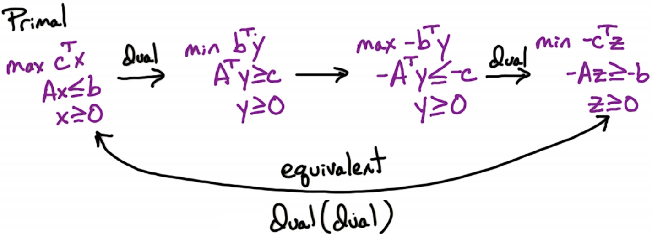

* + So: Dual(Dual) = Primal

Quiz: Formulate Dual LP

* Given

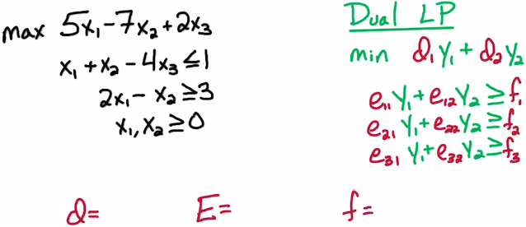

* Define the matrices for d (Objective Function), E (Constraint Matrix), and f (constraint values) for the Dual LP
  + A possible pitfall is the second constraint in the Primal LP will have to be converted to canonical form (so that’s: - 2x1 + x2 <= -3)
* Answer

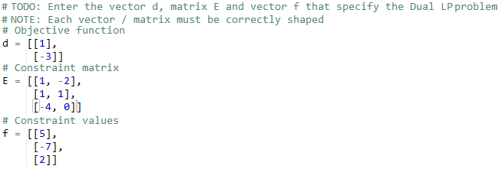

* Another way to view the answer:

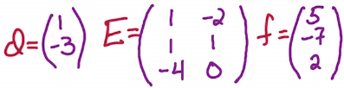

* + NOTE: E is a simple transpose!

Weak Duality

* **Weak Duality Theorem**: With a given feasible x for the Primal LP and a given feasible y for the Dual LP, CTX <= bTY
  + That is to say, the Primal LP objective function is the lower bound and the Dual LP objective function is the upper bound
* Corollary: If we find a feasible X and a feasible Y where CTX = bTY then X and Y are optimal
  + In order for this to work, BOTH the Primal LP AND Dual LP MUST be feasible and bounded
* Corollary 2: If the Primal LP is unbounded, then Dual LP is infeasible; if Dual LP is unbounded, then Primal LP is infeasible
  + Note this is only one direction: it could be the case where both the Primal LP and Dual LP are both infeasible (this statement only talks about the consequences of one being unbounded, not the consequences of one being infeasible)
* In order to check whether the Primal LP is unbounded, we check the Dual LP; if the Dual LP is infeasible, then the Primal LP is either unbounded OR infeasible
  + We don’t know which one as the theorem does not specify
  + If the Primal LP is feasible but its associated Dual LP is infeasible, it must be the case that the Primal LP is unbounded
    - This takes two feasibility questions to determine

Strong Duality

* **Strong Duality Theorem**: The Primal LP is feasible and bounded if and only if the Dual LP is feasible and bounded
  + An equivalent statement is the Primal LP has an optimal point x* iff the Dual LP has an optimal point y*
  + We also know that if this is the case, optimal x* will always equal optimal y*
    - CTX <= bTY
    - Given x*, we are guaranteed that it is an optimal solution (the Dual LP certifies this to be true)
* If we write this as Max-Flow = Min-Cut, the Primal LP (Max-Flow) has an objective function (which is the max flow size) and its equivalent to the Dual LP (Min-Cut) which has an objective function (capacity of min st-cut)
  + The Strong Duality Theorem can also be used to prove Max-Flow = Min-Cut